Website Improvement.
added a Meta Name=”description” to each page, counting this as 1 change
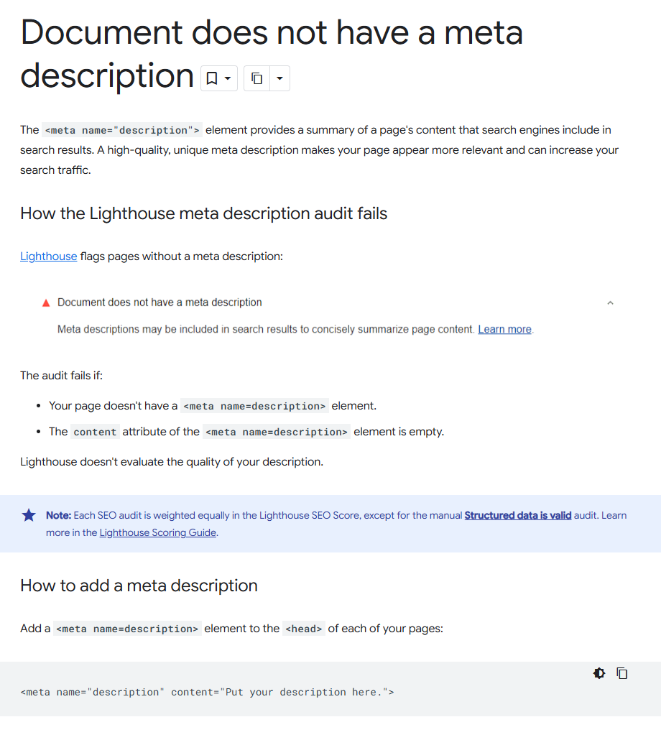
replaced ann frank screen shot with a jpg version to save load time and memory
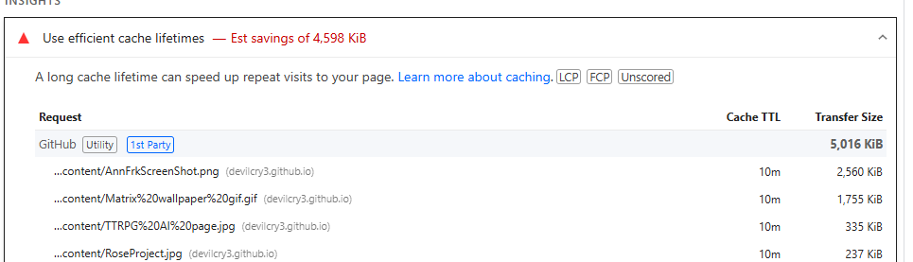
Did a scrub of Css doc to remove any unused classes or changes.
